SQL_Transactions Assignment

Note: This assignment has to be completely performed in MYSQL Workbench. Select your OS type and download workbench from the given link. https://dev.mysql.com/downloads/workbench/

The version of MYSQL Workbench used for this assignment is 8.0.27
You can use any other stable version.
Follow:
https://youtu.be/YSOY_NyOg40

- Transactions group a set of tasks into a single execution unit. Each transaction begins with a specific task and ends when all the tasks in the group successfully complete.
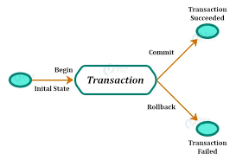

TRANSACTION PROPERTIES:

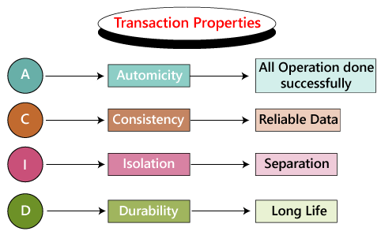

Before beginning, lets first create a table and insert data.
Create table ‘property’ having columns property_id, property_name,no-of_floors, ,no_of_flats, sqft_area

This is how our schema should look like
.
PROPERTY TABLE
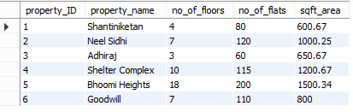

NOTE: TURN OFF THE AUTO COMMIT OPTION IN MYSQL WORKBENCH
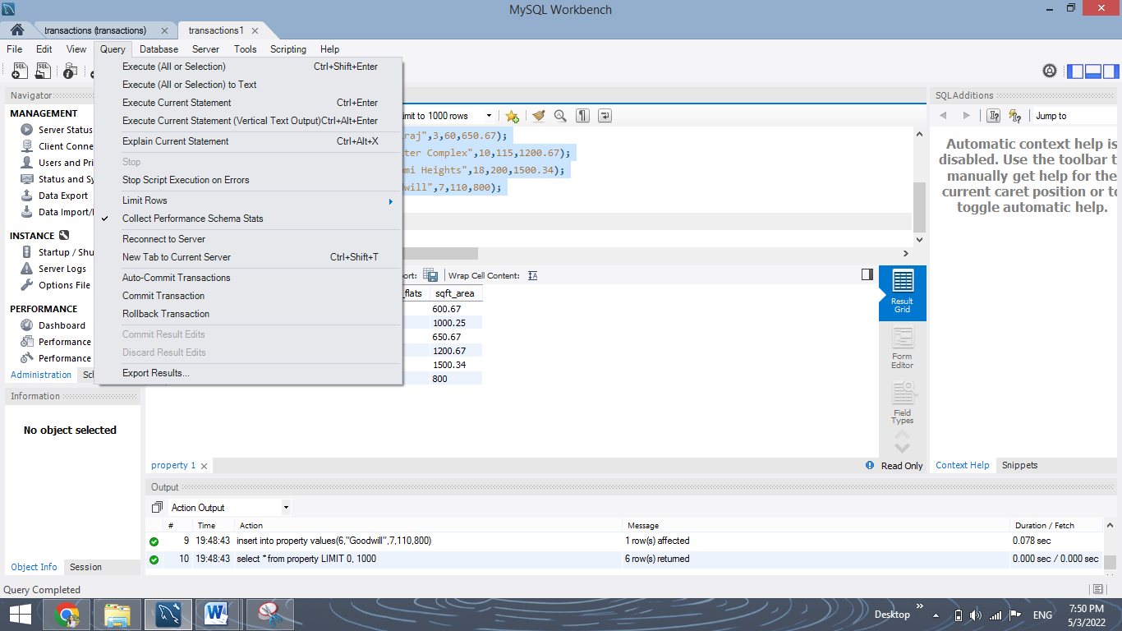

1. COMMIT: The COMMIT command saves all the transactions to the database since the last COMMIT or ROLLBACK command.
Syntax:
COMMIT;
Example:
DELETE FROM Student WHERE AGE = 20;
COMMIT;

Q1. Insert a row in the table and commit it.
YOUR QUERY HERE:
insert into property values(7,'Rekhi Residency',15,130,1600);
commit;
select * from property;
Output:
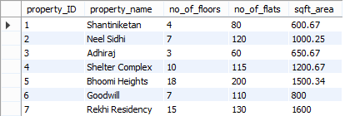

Q2. Update the Property table, change the value of flats to 65 for “Adhiraj” property and commit this.
YOUR QUERY HERE:
update property set no_of_flats=65 where property_name='Adhiraj';
commit;
select * from property;
Output:
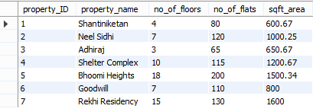

2. ROLLBACK: This command can only be used to undo transactions since the last COMMIT or ROLLBACK command was issued.
Syntax:
ROLLBACK;

Example:

DELETE FROM Student WHERE AGE = 20;
ROLLBACK;

Q3. Insert some rows in the table and rollback them.
YOUR QUERY HERE:
insert into property values(8,"Ashapuri Residency",5,50,700);
insert into property values(9,"Radhe Residency",7,50,700);
insert into property values(10,"Grow More",12,90,1200.8);
select * from property;
rollback;
select * from property;
Output:
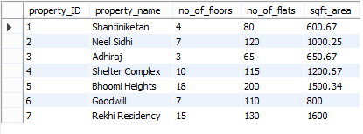

Q4. Delete a row in the table and rollback it.
YOUR QUERY HERE:
delete from property where property_name='Adhiraj';
select * from property;
rollback;
select * from property;
Output:


3. SAVEPOINT: creates points within the groups of transactions in which to ROLLBACK. A SAVEPOINT is a point in a transaction in which you can roll the transaction back to a certain point without rolling back the entire transaction.
Syntax for Savepoint command:
SAVEPOINT SAVEPOINT_NAME;
Syntax for rolling back to Savepoint command:
ROLLBACK TO SAVEPOINT_NAME;

Q5. Insert certain rows to the table and create a savepoint and rollback to this savepoint again after inserting another row.
YOUR QUERY HERE:
insert into property values(11,"Ambika heights",8,57,1000);
insert into property values(12,"Anmol plaza",7,42,900);
select * from property;
savepoint s1;
insert into property values(13,"Satyam heights",10,100,1100);
select * from property;
rollback to s1;
select * from property;
Output after inserting data and creating savepoint:
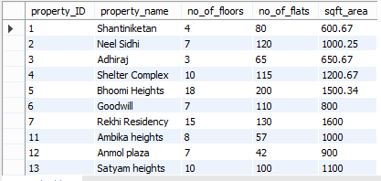

Output after inserting another row and rolling back to savepoint:
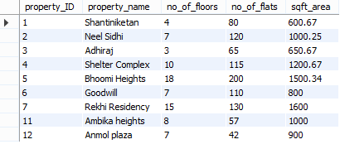

Q6. Delete records having floors greater than equal to 10 and create a savepoint. Insert another row after this and rollback to the savepoint created above.

YOUR QUERY HERE:
select * from property;
delete from property where no_of_floors>=10;
savepoint s2;
insert into property values(14,"Nilgiri heights",10,80,1400);
select * from property;
rollback to s2;
select * from property;

Output after deleting records, creating savepoint and inserting a row:
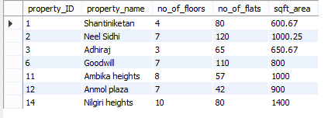

Output after rolling back to the savepoint:
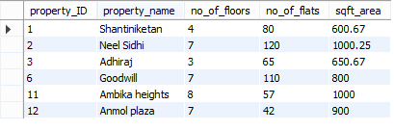

Congratulations, you have just completed an assignment!!


FEEDBACK FORM:

https://docs.google.com/forms/d/e/1FAIpQLScnAaAKvph9R3vINyCtOOMiav-tSMsRGlJReMaHyPjsXDlTIA/viewform

